**Install JBoss EAP 7.x on RHEL 8**

**Install Java Development Kit (JDK):**

**[root@jboss Downloads]#** yum install java-11-openjdk-devel –y

**Verify the installed Java version on your system**.

**[root@jboss Downloads]# java –version**

openjdk 11.0.17 2022-10-18 LTS

OpenJDK Runtime Environment (Red_Hat-11.0.17.0.8-2.el8_6) (build 11.0.17+8-LTS)

OpenJDK 64-Bit Server VM (Red_Hat-11.0.17.0.8-2.el8_6) (build 11.0.17+8-LTS, mixed mode, sharing)

**Download JBoss EAP 7.x on RHEL 8**

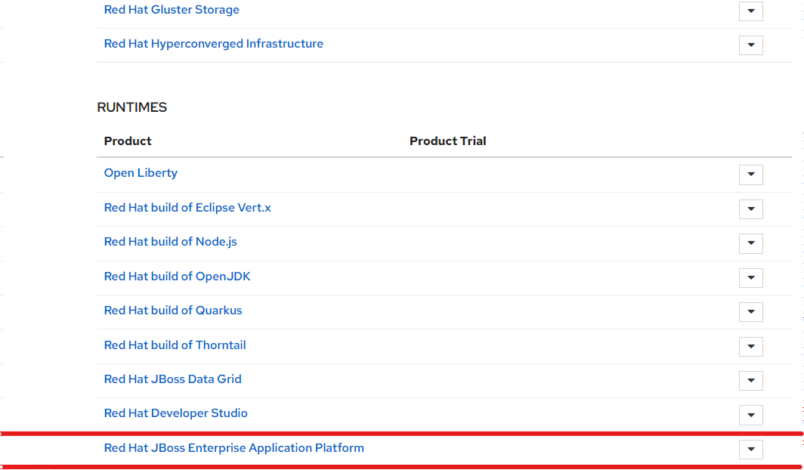

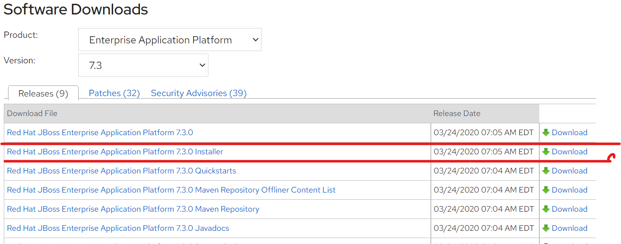

**[root@jboss Downloads]# ls**

jboss-eap-7.3.0-installer.jar

**[root@jboss Downloads**]# mv jboss-eap-7.3.0-installer.jar $HOME

**THROUGH CONSOLE**

**[root@jboss ~]#** java -jar jboss-eap-7.3.0-installer.jar -console

Select your language below :

0: English

1: 中文

2: Deutsch

3: français

4: 日本語

5: português

6: español

Please choose [0] :

**0**

END USER LICENSE AGREEMENT

RED HAT JBOSS(r) MIDDLEWARE(tm)

Copyright (c) 2013 Red Hat, Inc. All rights reserved. Red Hat, JBoss and the JBoss logo are registered trademarks of Red Hat, Inc. All other trademarks are the property of their respective owners.

press 1 to continue, 2 to quit, 3 to redisplay.

**1**

Select the installation path: [/root/EAP-7.3.0]

press 1 to continue, 2 to quit, 3 to redisplay.

1

Select the packs you want to install:

1 [x] [Required] [Red Hat JBoss Enterprise Application Platform] (29.79 MB)

2 [x] [AppClient] (31.89 KB)

3 [x] [Docs] (16.37 MB)

4 [x] [Required] [Modules] (184.66 MB)

5 [x] [Required] [Welcome Content] (2.1 MB)

Total Size Required: 232.95 MB

Press 0 to confirm your selections

Please select which packs you want to install

0

Pack Selection Done

press 1 to continue, 2 to quit, 3 to redisplay.

1

Create an Administrative User

This user will be added to the host container's management realm for administrative purposes. It can be used to access the management console, the management CLI, or other applications secured in this realm.

For minimal security, the password should be at least eight characters long, with one alphabetic character, one digit, and one non-alphanumeric symbol excluding "&".

Admin username: [admin]

harish

Admin password: []

******

Confirm admin password: [******]

******

Validation warning:

Password should have at least eight characters.

Password should have at least one digit.

Password should have at least one non-alphanumeric symbol.

press 1 to continue, 2 to quit, 3 to redisplay.

1

[ Starting to unpack ]

[ Processing package: Red Hat JBoss Enterprise Application Platform (1/5) ]

[ Processing package: AppClient (2/5) ]

[ Processing package: Docs (3/5) ]

[ Processing package: Modules (4/5) ]

[ Processing package: Welcome Content (5/5) ]

[ Unpacking finished. ]

Configure Runtime Environment

There are several additional options for configuring Red Hat JBoss Enterprise Application Platform now that the server has been installed. Each option can be individually chosen, and will be configured in the order displayed upon pressing "Next". What would you like to do now?

0 [x] Perform default configuration

1 [ ] Perform advanced configuration

Input Selection:

press 1 to continue, 2 to quit, 3 to redisplay.

1

[ Starting to unpack ]

[ Processing package: Red Hat JBoss Enterprise Application Platform (1/5) ]

[ Processing package: AppClient (2/5) ]

[ Processing package: Docs (3/5) ]

[ Processing package: Modules (4/5) ]

[ Processing package: Welcome Content (5/5) ]

[ Unpacking finished. ]

Configure Runtime Environment

There are several additional options for configuring Red Hat JBoss Enterprise Application Platform now that the server has been installed. Each option can be individually chosen, and will be configured in the order displayed upon pressing "Next". What would you like to do now?

0 [x] Perform default configuration

1 [ ] Perform advanced configuration

Input Selection:

press 1 to continue, 2 to quit, 3 to redisplay.

1

[ Starting processing ]

Starting process Logging installation information (1/3)

IzPack variable state written to /root/EAP-7.3.0/installation/InstallationLog.txt

Starting process Adding admin user (2/3)

Starting process Cleanup extraneous folders and tepmorary files (3/3)

Installation has completed successfully.

Application installed on /root/EAP-7.3.0

Would you like to generate an automatic installation script and properties file? (y/n) [n]:

y

Select path for the automatic installation script: [/root/EAP-7.3.0/auto.xml]

XML written successfully.

[ Console installation done ]

**[root@jboss ~]#** mkdir boss

**[root@jboss ~]# cd boss/**

**[root@jboss ~]#** ls

anaconda-ks.cfg Music

boss Pictures

Desktop Public

Documents 'softwareDetail.html?softwareId=80101'

Downloads Templates

EAP-7.3.0 Videos

initial-setup-ks.cfg wget-log

jboss-eap-7.3.0-installer.jar

**[root@jboss ~]#** cd boss/bin

**[root@jboss bin]#** ls

add-user.bat domain.sh product.conf

add-user.properties elytron-tool.bat service.bat

add-user.ps1 elytron-tool.ps1 standalone.bat

add-user.sh elytron-tool.sh standalone.conf

appclient.bat init.d standalone.conf.bat

appclient.conf jboss-cli.bat standalone.conf.ps1

appclient.conf.bat jboss-cli-logging.properties standalone.ps1

appclient.conf.ps1 jboss-cli.ps1 standalone.sh

appclient.ps1 jboss-cli.sh vault.bat

appclient.sh jboss-cli.xml vault.ps1

client jboss-server-migration.bat vault.sh

common.bat jboss-server-migration.sh wildfly-elytron-tool.jar

common.ps1 jconsole.bat wsconsume.bat

common.sh jconsole.ps1 wsconsume.ps1

domain.bat jconsole.sh wsconsume.sh

domain.conf jdr.bat wsprovide.bat

domain.conf.bat jdr.ps1 wsprovide.ps1

domain.conf.ps1 jdr.sh wsprovide.sh

domain.ps1 launcher.jar

[root@jboss ~]# ls

anaconda-ks.cfg Music

boss Pictures

Desktop Public

Documents 'softwareDetail.html?softwareId=80101'

Downloads Templates

EAP-7.3.0 Videos

initial-setup-ks.cfg wget-log

jboss-eap-7.3.0-installer.jar

**[root@jboss ~]#** $HOME/EAP-7.3.0/bin/standalone.sh

=========================================================================

JBoss Bootstrap Environment

JBOSS_HOME: /root/boss

JAVA: java

JAVA_OPTS: -server -Xlog:gc*:file="/root/boss/standalone/log/gc.log":time,upt imemillis:filecount=5,filesize=3M -Xms1303m -Xmx1303m -XX:MetaspaceSize=96M -XX: MaxMetaspaceSize=256m -Djava.net.preferIPv4Stack=true -Djboss.modules.system.pkg s=org.jboss.byteman -Djava.awt.headless=true --add-exports=java.base/sun.nio.ch =ALL-UNNAMED --add-exports=jdk.unsupported/sun.misc=ALL-UNNAMED --add-exports=jd k.unsupported/sun.reflect=ALL-UNNAMED

=========================================================================

02:10:42,771 INFO [org.jboss.modules] (main) JBoss Modules version 1.9.1.Final- redhat-00001

02:10:46,087 INFO [org.jboss.msc] (main) JBoss MSC version 1.4.11.Final-redhat-00001

02:10:46,178 INFO [org.jboss.threads] (main) JBoss Threads version 2.3.3.Final-redhat-00001

`

Here you can access the web console using the URL **http://127.0.0.1:9990**

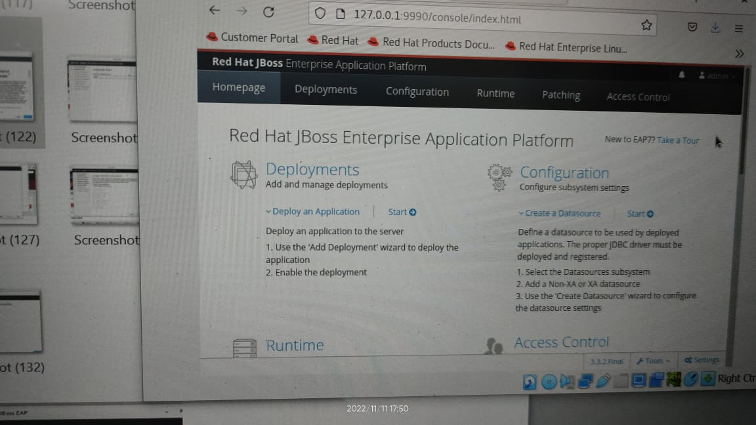

THROUGH GUI

**[root@jboss ~]#** java -jar jboss-eap-7.3.0-installer.jar 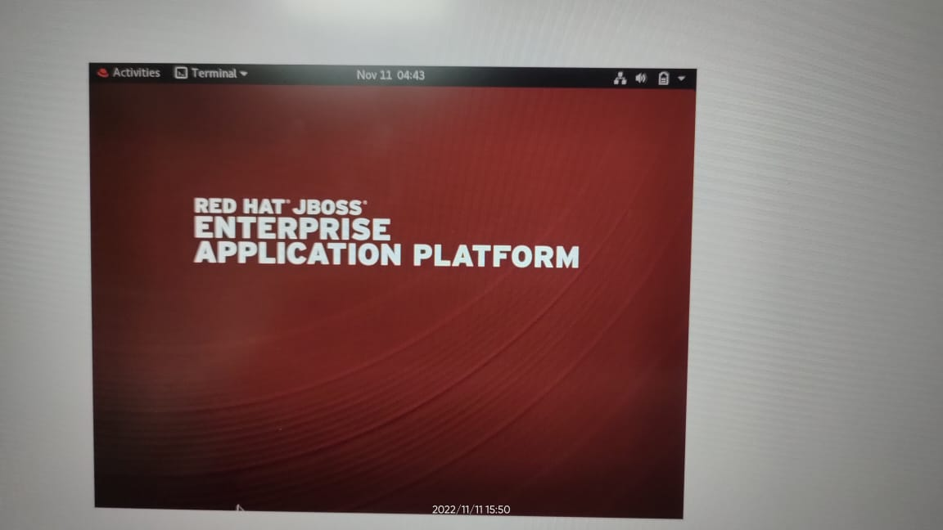

Next small box will be open to select the language

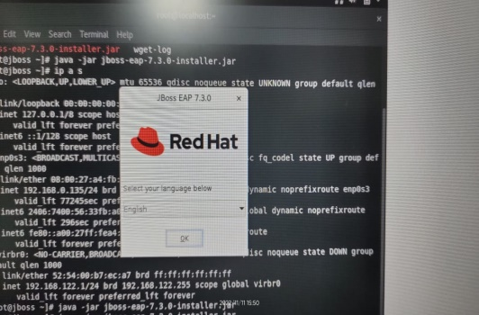

1. **License Agreement**

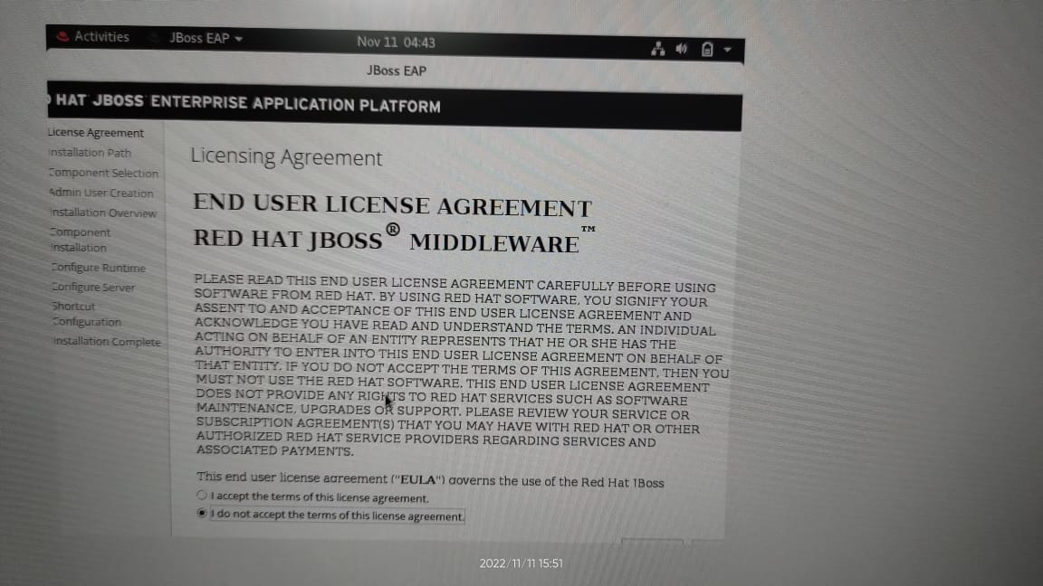

1. **Installation path**

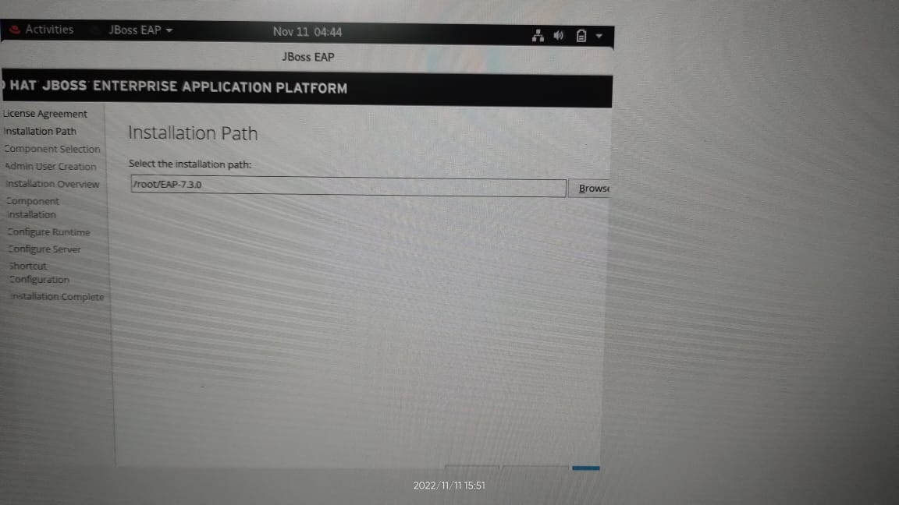

1. **Component selection**

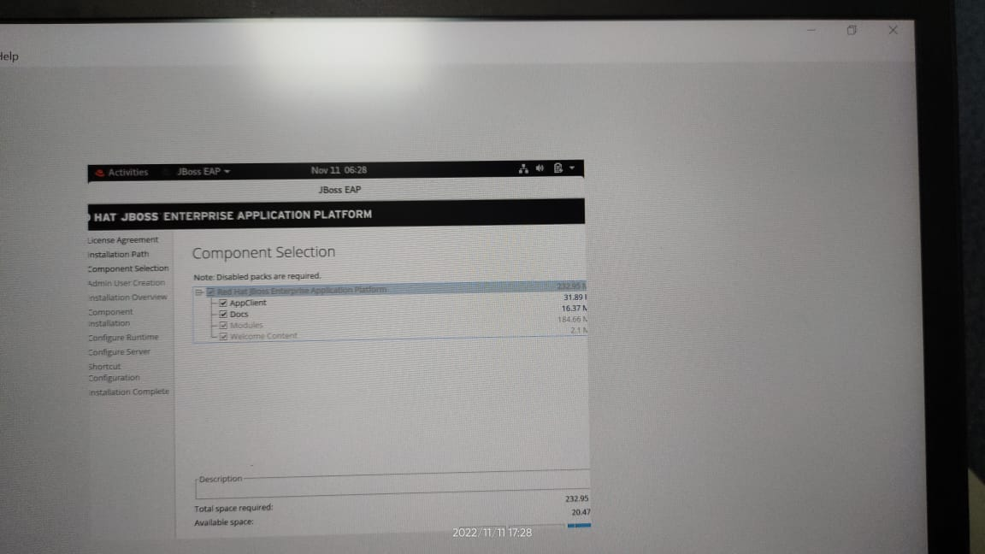

**4.Admin User Creation**

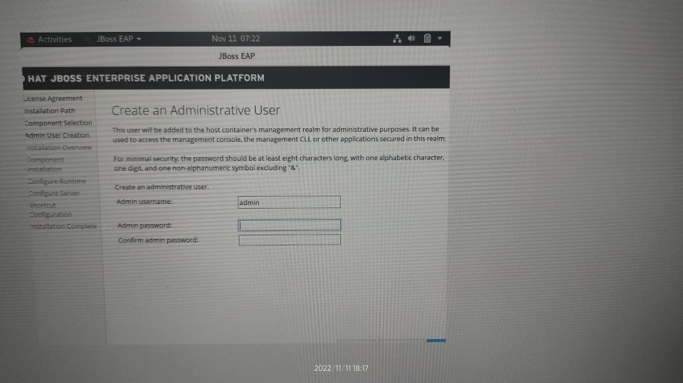

**5.Installation Overview**

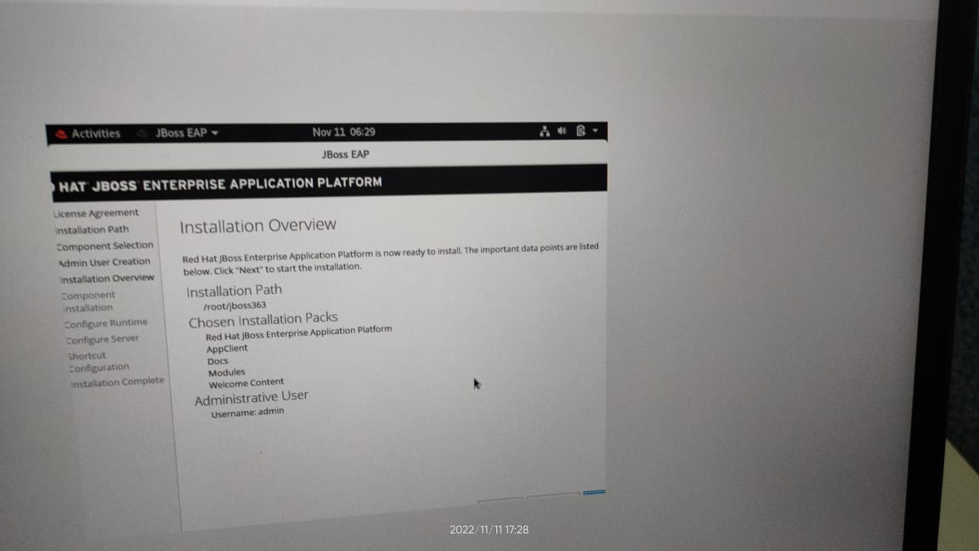

**6. Component Installation**

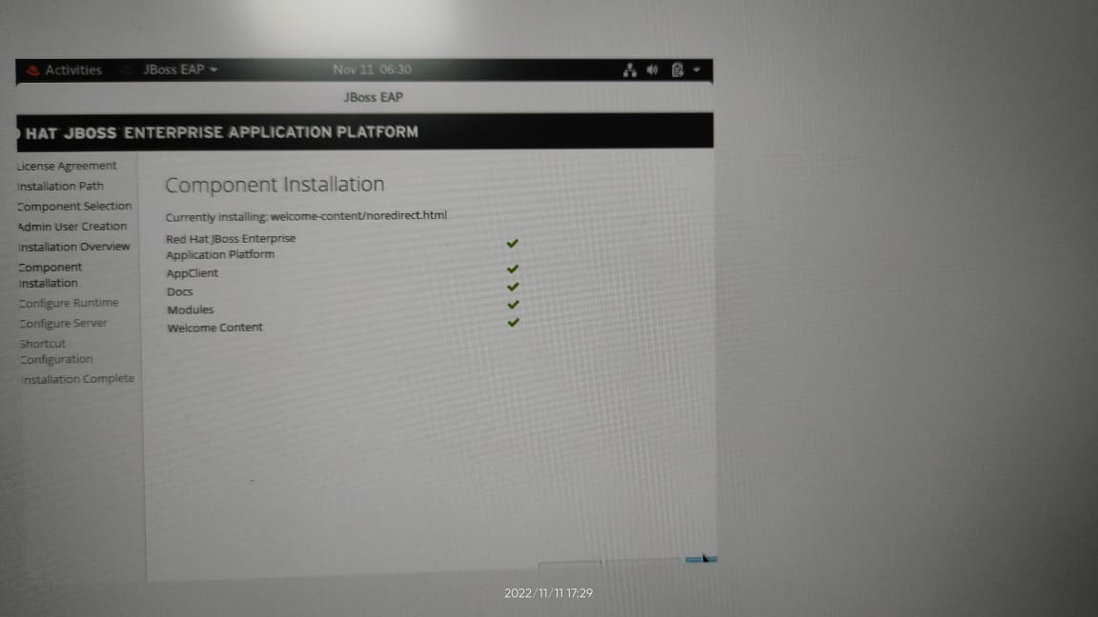

**7.Configure Runtime**

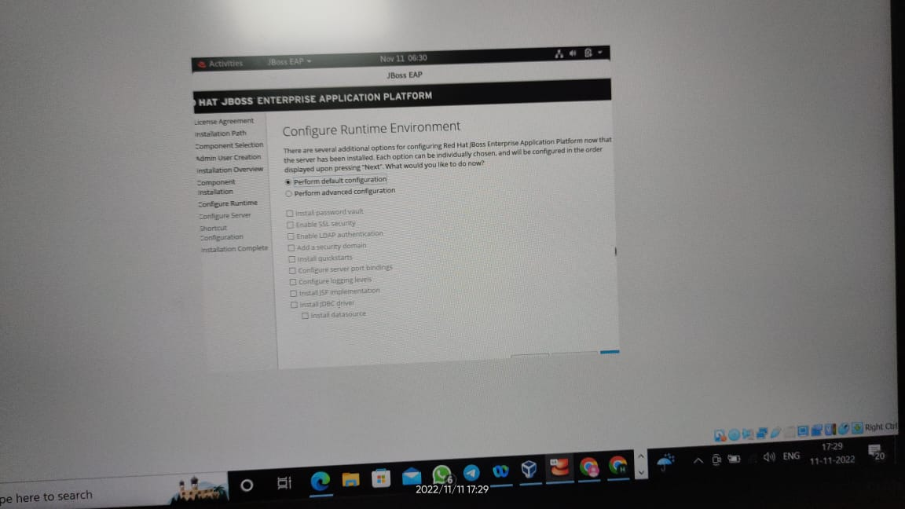

**8. Configure server**

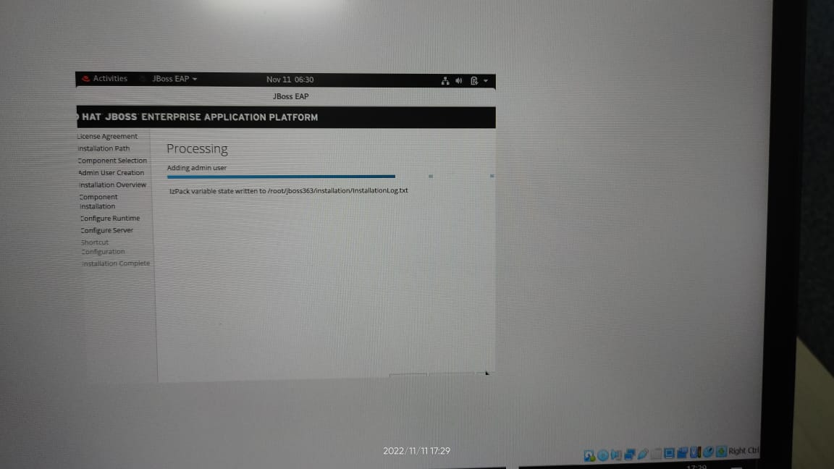

**9. Installation complete**

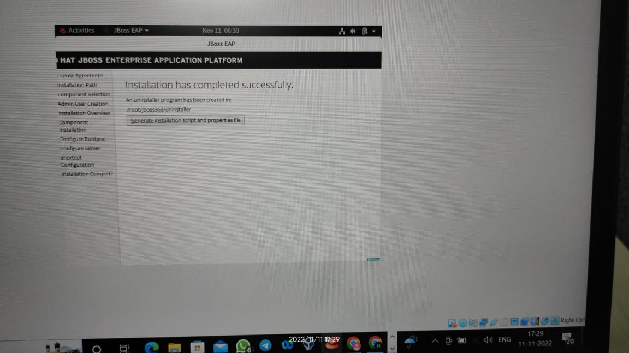

**After this we need to run the below command**

**[root@jboss ~]#** boss/bin/standalone.sh -Dboss.bind.address=127.0.0.1

=========================================================================

JBoss Bootstrap Environment

JBOSS_HOME: /root/boss

JAVA: java

JAVA_OPTS: -server -Xlog:gc*:file="/root/boss/standalone/log/gc.log":time,upt imemillis:filecount=5,filesize=3M -Xms1303m -Xmx1303m -XX:MetaspaceSize=96M -XX: MaxMetaspaceSize=256m -Djava.net.preferIPv4Stack=true -Djboss.modules.system.pkg s=org.jboss.byteman -Djava.awt.headless=true --add-exports=java.base/sun.nio.ch =ALL-UNNAMED --add-exports=jdk.unsupported/sun.misc=ALL-UNNAMED --add-exports=jd k.unsupported/sun.reflect=ALL-UNNAMED

=========================================================================

02:10:42,771 INFO [org.jboss.modules] (main) JBoss Modules version 1.9.1.Final- redhat-00001

02:10:46,087 INFO [org.jboss.msc] (main) JBoss MSC version 1.4.11.Final-redhat-00001

02:10:46,178 INFO [org.jboss.threads] (main) JBoss Threads version 2.3.3.Final-redhat-00001

Here you can access the web console using the URL **http://127.0.0.1:9990**

